How to Deploy Code to the Robot: Chase Bowen

Step 1: Make sure that you have all of the necessary applications installed on your computer. You will need VSCode, the VSCode Java and Wpilib plugins, and the National Instrument tools (FRC DriverStation/Shuffleboard from the NI Update Suite).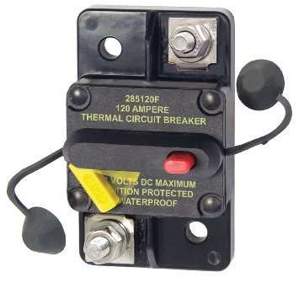

Step 2: Turn the robot on. This can be done by pushing the lever of the circuit breaker back into the circuit. In the picture to the left, you would push the yellow bar in to power on the robot and push the red button to power the robot off. Also, make sure there is a battery connected to the robot. If not, get a battery, plug it in, and then connect the circuit.

Step 3: Connect to the robot under the Network Tab (where you go to find WiFi sources on the computer). The name of the robot you are trying to connect to should appear after a minute or two. Click on that name and connect to it. **The name will only appear if the robot is turned on.** The connection name for Taz is “620_Testbot” and the connection name for the prototype bot is “620_Pinchpoint”.

Step 4: Get the code you are trying to deploy to the robot ready. Select the project you want to send to the robot, press CTRL+Shift+P to access the command palette, and search the keyword “wpilib”. Alternatively, you can press the “W” icon next to the file tabs to access the WPILib portion of the palette immediately. Then, press on “WPILib: Build Robot Code” and then wait for the terminal to say “Build Successful”. Open up the command palette again and press on “WPILib: Deploy Robot Code”. Wait for the terminal to say “Deploy Successful”. **Code can be built at any time, but a connection to a robot is required to deploy code.**

Step 5: Plug an XBox Controller or Joystick into one of the USB ports on your computer. Open up DriverStation and check to see if the three boxes under the battery graphic are green. “Communications” will be green if your computer is connected to the robot, “Robot Code” will be green if your code successfully deployed to the robot, and “Joysticks” will be green if the computer detects a controller. In most cases, you will be trying to drive the robot, so click on the button that says “TeleOperated” on the left-hand side. Press “Autonomous” if you are not driving the robot. The default tab (“Operation”) is the top tabon the left edge. Other useful tabs are “Diagnostics” (second from top), which shows all of the computer’s connections, and “USB Devices” (second from bottom) which shows controller inputs.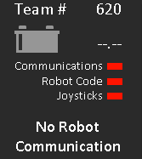

Step 6: You are now ready to test the robot. Make sure that the robot is in a safe spot and alert others that the robot will be turning on. Press “Enable” on the main tab and then you are able to control the robot. Test what functions you need to test and then press the “Disable” button to stop all robot functions. **Never leave the robot unattended while it is enabled and disable the robot immediately if anything goes wrong.** The space button also acts as a disable button, so press that in case of an emergency.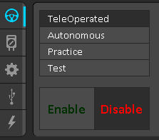

Step 7: Once the robot is disabled, disconnect from it in the Networks Tab if someone else wants to test their code on it. If you need to keep testing code, make edits to it in VSCode and then rebuild and redeploy it.

If you follow these steps, then you will have successfully controlled the robot.

A Few Other Notes:

* While Shuffleboard is not required to run the robot, it contains a lot of useful information about the robot. Go to the “Setup” tab in DriverStation (the gear in the center of the toolbar) and set Dashboard Type to Shuffleboard. Then, open the application and start adding widgets from the sidebar on the left. Any widgets written in code will appear on the dashboard when the robot is enabled.
* When code is deployed to the robot, it is saved in the robot’s RoboRIO. This means that other computers connected to the robot can run the latest code deployed to the robot. So, if someone else needs to drive the robot, they can drive it on another computer from the code you deployed while you work on other things.
* If you are unable to connect to the robot through the network, you can still connect to the robot by using an ethernet cable. Connect one end of the cord into the ethernet port of the RoboRIO and the other end into the ethernet/USB port on your computer (depending on the cable).

Happy Coding!

Chase Bowen